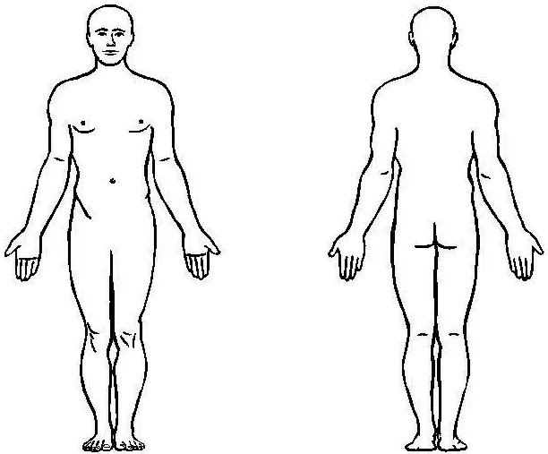
PATIENT HISTORY FORM – Vestibular/Balance PLEASE PRINT
NAME: ____________________________________________________

Age: ________ Most Recent Doctors Appt: _______________________

When did your symptoms begin? __________________________

Was there an illness/injury that caused these symptoms? ______________

Do you have a history of concussions? ___________________________

Have you fallen?________ Date of most recent fall _________________

Have you received home health? Yes____ No____ Agency_________________

Please check if you have experienced any of the following conditions:
Recent unexplained weight loss _____ Recent high fever _______
Involuntary loss of urine or stool _____ Numbness in groin ______
Severe night pain or sweats _______ Weakness of hands _____  Severe headaches______ Neck pain _______  Recent fall or trauma _____________ Back Pain ________  Difficulty coordinating legs while walking_______ | Please mark on the drawing where your pain is

Please circle one:
Rate your headache:(1=minimal 10=severe) At its worst: 0 1 2 3 4 5 6 7 8 9 10 At its best: 0 1 2 3 4 5 6 7 8 9 10
Rate your dizziness:(1=minimal 10=severe) At its worst: 0 1 2 3 4 5 6 7 8 9 10 At its best: 0 1 2 3 4 5 6 7 8 9 10
Rate your nausea: :(1=minimal 10=severe) At its worst: 0 1 2 3 4 5 6 7 8 9 10 At its best: 0 1 2 3 4 5 6 7 8 9 10

Have you had any other treatment for this condition? Yes_____ No_____

If Yes, please check: Chiropractic _____ CT Scan_____ EMG/NCV_________ Injections________ Medication____________ MRI_________ Surgery______ X-ray__________ Other_____________________________

Do you have any of the following conditions? (Please check all that apply)
Anxiety/Nervousness______ Cancer__________________ Circulatory Prob.________ Diabetes_________
Dizzy Spells_____________ Heart Disease/Trouble______ High Blood Pressure_____ HIV/HEP-C________
History of steroid usage____ Osteoarthritis___________ Pacemaker_______ Rheumatoid Arthritis_______
Skin Disorders/Sensitivity____ Pregnant________ Vision trouble/Hearing Loss _______ Other_________

Do you have metal implanted in your body? YES_____ NO_____ If yes, where? _________________________

List all Prescription MEDICATIONS you are currently taking___________________________________________________________

Have you ever had Physical Therapy? Yes_____ No_____ If yes, indicate at what office and for what_____________________
Within this year have you been seen at another physical therapy clinic? Yes____ No____ How many visits_______

HOW DID YOU HEAR ABOUT US? Doctor_____ Friend ____ Other (please describe) _________________________________

Sign up for our Newsletter: Email address: ____________________________________________________

AUTHORIZATION FOR MEDICAL TREATMENT AND AUTHORIZATION FOR RELEASE OF INFORMATION
I consent to physical therapy treatment/provisions of modalities and procedures, as indicated by the therapist and/or physician. I have reviewed and agree with all office policies including Attendance and Patient Rights and Responsibilities.

PATIENT SIGNATURE: __________________________________________ DATE: ___________________ GUARDIAN’S SIGNATURE (if patient is under 18): ___________________________________________________

